Name: |  | _______________________________________ |  |  |  |  | Date: __________
 |  | Year 9 Mathematics  53+2  = %  Test 7 – Algebra, 2015
Total Time: |  | 60 minutes |  |  |  | BONUS MARKS:   2 Quality notes   1 Simple notes   0 No notes
Total Reading: |  | 5 minutes
Total Working: |  | 55 minutes
Weighting: |  | 10 % of the year.
SECTION 1 - CALCULATOR FREE
Time: |  |  | 17 minutes | Equipment Allowed: | Nil
Marks: |  |  | 16
1. | [4 Marks: 1, 1, 1, 1]  Write an algebraic expression for each of the following:
a) | 7 timesis added to 1 b) The product of and .
c) | is divided by 6 times d) 2 times is subtracted from 5 times
2. | [4 marks: 1, 1, 1, 1]  Simplify the following expressions:
a) | 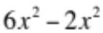 b) 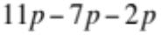
c) | 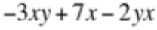 d) 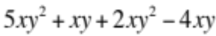

3. | [4 marks: 1, 1, 1, 1]  Simplify the following expressions:
a) | 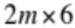 b) 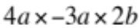
b) | 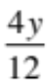 d) 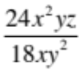
4. | [4 marks: 1, 1, 1, 1]  If 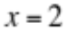 and 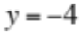, use substitution to evaluate the following expressions:
a) | 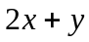 b) 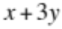
c) | 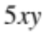 d) 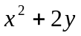

~ END OF SECTION ONE ~
Name: | ___________________________________________________ |  |  |  | Date: ___________
SECTION 2: CALCULATOR ASSUMED
Time: |  | 40 minutes | Equipment Allowed: | ½ page notes (A4 one side), Scientific calculator
Marks for Section 2: |  | 37 | Equipment Allowed:

5. | [16 Marks: 1, 1, 2, 2, 2, 2, 3, 3]  Expand and simplify the following:
a) | 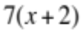 b) 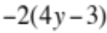
c) | 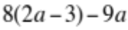 d) 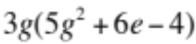
e) | 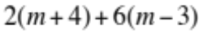 f) 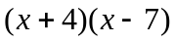
g) | 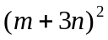 h) 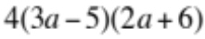

6. | [4 Marks: 2, 2]  Expand and simplify the following:
a) | 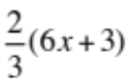 b) 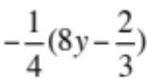
7. | [8 Marks: 1, 1, 1, 1, 2, 2]  Factorise the following:
a) | 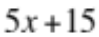 b) 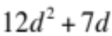
c) | 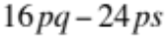 d) 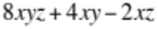
e) | 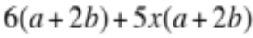 f) 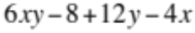

8. | [9 Marks: 1, 2, 2, 2, 2]  Factorise the following:
a)  b)  c)  d)  e) | A rectangular garden bed has a length of 15 metres and a width of 8 metres. It is surrounded by a path  of width x metres.  Determine the area of the garden bed  Write an expression for the total area of the garden bed and path in factorised form.  Expand the expression you found in b)  Write an expression for the area of the path only (in terms of x).  Write an equation that could be solved to find the width of the path if the area of the path is 200 m²

~ END OF SECTION TWO ~

